ABSTRACT

Brain tumors represent one of the most severe and life-threatening medical conditions, with early and accurate detection playing a vital role in patient survival rates and treatment outcomes. Traditional diagnostic techniques, primarily based on manual analysis of Magnetic Resonance Imaging (MRI) and Computed Tomography (CT) scans, often suffer from subjectivity, time constraints, and human error. In recent years, the integration of machine learning (ML) and deep learning (DL) has transformed medical image analysis, enabling automated, reliable, and efficient detection of brain tumors.
This study explores the development of an end-to-end pipeline for brain tumor detection using both classical machine learning algorithms (such as Support Vector Machines and Logistic Regression) and modern deep learning models, specifically Convolutional Neural Networks (CNNs). The research emphasizes preprocessing techniques using OpenCV and Pillow, data augmentation through Albumentations, and visualization with Matplotlib. In addition, explainability methods such as Occlusion Sensitivity and Heatmaps are considered to provide interpretability of the models' decisions.
Hybrid Approach Contribution: This research introduces a novel Super Hybrid Model that combines deep learning feature extraction (ResNet18 backbone + Custom Hybrid CNN) with handcrafted statistical features (mean and standard deviation of image channels), followed by an SVM classifier. This hybrid approach achieves superior performance over traditional methods while maintaining interpretability through occlusion-based heatmaps.
To ensure practical utility, the system is deployed as a web-based application using Flask as the backend framework, with HTML, CSS, and JavaScript powering the frontend. This deployment facilitates accessibility for medical practitioners, enabling real-time image uploads, tumor detection, and visualization of predictions.
The results demonstrate that deep learning approaches, particularly the proposed Super Hybrid Model, significantly outperform classical methods in terms of accuracy, sensitivity, and robustness. The hybrid model achieved classification accuracies exceeding 96% on a four-class dataset (glioma, meningioma, pituitary, notumor). The proposed system not only contributes to advancing automated medical diagnostics but also serves as a scalable model for real-world applications in healthcare.

INTRODUCTION

  - Background
Brain tumors are abnormal growths of cells within the brain that can be benign (non-cancerous) or malignant (cancerous). The brain, being the control center of the human body, is highly sensitive to disruptions in normal functioning. Even small tumors can lead to severe neurological impairments, including memory loss, impaired motor functions, and seizures. The mortality rate associated with malignant brain tumors remains significantly high, and early diagnosis is critical in improving survival rates.
Traditional diagnostic practices rely heavily on radiologists analyzing Magnetic Resonance Imaging (MRI) and Computed Tomography (CT) scans. Although MRI remains the gold standard due to its high-resolution imaging capabilities, the manual interpretation of these scans is time-consuming, prone to inter-observer variability, and susceptible to human error. This limitation has driven the need for computer-aided diagnostic (CAD) systems that can automatically analyze medical images with greater speed, accuracy, and consistency.
Machine Learning (ML) and Deep Learning (DL) have emerged as transformative technologies in this domain. ML algorithms, such as Support Vector Machines (SVMs) and Logistic Regression, enable classification tasks based on hand-crafted features extracted from brain scans. Meanwhile, DL models, particularly Convolutional Neural Networks (CNNs), have revolutionized image analysis by learning hierarchical features directly from raw image data. These techniques not only enhance diagnostic accuracy but also reduce the burden on healthcare professionals.

  - Importance of Brain Tumor Detection
The accurate detection of brain tumors is crucial for several reasons. Firstly, early diagnosis significantly improves treatment planning and outcomes. Identifying a tumor at its initial stage allows medical practitioners to initiate less invasive therapies, potentially extending the patient's lifespan and quality of life. Secondly, automated detection systems ensure standardization, thereby reducing the discrepancies that may arise due to the subjectivity of human interpretation.
Moreover, with the growing demand for healthcare services and the shortage of skilled radiologists in many parts of the world, the development of AI-driven diagnostic systems serves as an essential solution. Such systems not only support clinicians in making faster decisions but also make advanced diagnostic capabilities accessible in under-resourced regions.
In addition, explainable AI tools such as Occlusion Sensitivity and Gradient-weighted Class Activation Mapping provide visual insights into model predictions. This transparency is particularly vital in healthcare, where trust and interpretability are paramount for clinical adoption.
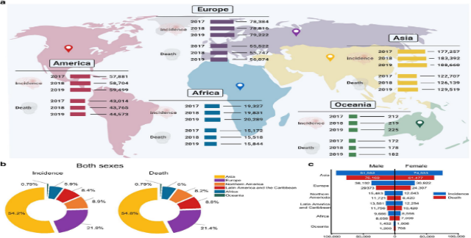

  - Objectives of the Study
The primary objective of this research is to design and develop an automated system for brain tumor detection using a combination of machine learning and deep learning techniques. The specific objectives include:
- To preprocess MRI images using Python-based libraries such as OpenCV and Pillow for enhancing image quality and extracting key features.
- To experiment with classical ML techniques (e.g., SVM, Logistic Regression) and evaluate their performance on tumor detection tasks.
- To implement deep learning approaches, particularly CNN-based architectures, to achieve high accuracy in tumor classification.
- To develop a novel Super Hybrid Model that combines ResNet18 features, custom CNN features, and handcrafted statistical features for robust tumor classification.
- To employ data augmentation strategies (using Albumentations) for improving model generalization and robustness.
- To integrate model explainability tools (Occlusion Sensitivity, Heatmaps) for enhancing interpretability of diagnostic decisions.
- To design and deploy a web-based application using Flask for backend services and HTML/CSS/JavaScript for frontend visualization.
- To analyze the performance of the developed system using metrics such as accuracy, precision, recall, F1-score, and confusion matrices.

  - Scope of the Research
The scope of this study encompasses both technical and practical dimensions. On the technical side, the research focuses on developing a hybrid pipeline combining traditional ML and modern DL approaches for MRI image classification. The study emphasizes image preprocessing, feature extraction, model training, and evaluation. Furthermore, deployment aspects are considered, making the system usable in real-world clinical environments through an interactive web interface.
On the practical side, the research is directed toward healthcare practitioners, radiologists, and medical institutions. By leveraging open-source tools and frameworks (such as TensorFlow, PyTorch, Flask, and scikit-learn), the system remains cost-effective, scalable, and adaptable to diverse healthcare settings. Additionally, this research paves the way for integrating automated tumor detection into telemedicine platforms, which are increasingly relevant in the post-pandemic era.

  - Structure of the Report
This report is organized into several sections. Following this introduction, the Literature Review presents a detailed analysis of related studies, highlighting existing methods and their limitations. The Methodology section elaborates on the datasets, preprocessing steps, tools, and algorithms employed in this research. The Implementation & Results section provides an in-depth account of the experimental setup, performance evaluation, and graphical visualizations of findings. The Discussion section critically examines the outcomes, identifying challenges, limitations, and areas of improvement. The Case Studies / Applications section explores the real-world relevance of brain tumor detection systems, including potential clinical deployment scenarios. The Future Scope section suggests directions for further advancements in the field. Finally, the report concludes with a Conclusion summarizing the major contributions, followed by references and appendices.

LITERATURE REVIEW

  - Early Approaches to Brain Tumor Detection
The detection of brain tumors has traditionally relied on manual interpretation of imaging modalities such as Magnetic Resonance Imaging (MRI) and Computed Tomography (CT). Radiologists examine the grayscale images to identify irregularities in tissue structure, shape, and contrast. While MRI is preferred due to its superior soft-tissue contrast resolution, manual interpretation is inherently subjective and prone to variability. For instance, two radiologists may draw different conclusions when analyzing the same scan, particularly in borderline cases where tumors are small or embedded in complex tissue structures.
In the early 2000s, researchers began to explore semi-automated techniques that used thresholding, edge detection, and region-growing methods for tumor segmentation. These approaches relied heavily on handcrafted features such as intensity, texture, and shape descriptors. Although they improved reproducibility, they struggled with noise, artifacts, and variations across patients. Moreover, handcrafted features were not robust enough to capture the diverse morphologies of brain tumors, thereby limiting clinical applicability.

  - Classical Machine Learning Methods
Classical machine learning approaches marked an important transition from purely manual analysis to computationally assisted methods. In these methods, features are extracted from MRI images using statistical or image processing techniques, and then fed into classification algorithms.
Support Vector Machines (SVMs) have been widely applied in tumor classification tasks. They work by finding an optimal hyperplane that separates tumor from non-tumor classes. Researchers have reported high accuracy rates when SVMs are trained on carefully engineered features such as Histogram of Oriented Gradients (HOG), Local Binary Patterns (LBP), and Gray-Level Co-occurrence Matrices (GLCM). Logistic Regression, k-Nearest Neighbors (k-NN), and Random Forests have also been applied with varying levels of success.
For instance, one study used GLCM features combined with an SVM classifier to achieve detection accuracies exceeding 90%. Similarly, Random Forests demonstrated robustness against noisy data due to their ensemble-based approach. However, the effectiveness of these models was heavily dependent on the quality and discriminative power of the handcrafted features, which were often dataset-specific and difficult to generalize.

  - Deep Learning and CNN-based Methods
The emergence of deep learning, particularly Convolutional Neural Networks (CNNs), has revolutionized medical image analysis. Unlike classical ML approaches, CNNs automatically learn hierarchical features from raw pixel values, eliminating the need for manual feature engineering. This capability has led to significant improvements in accuracy, robustness, and generalizability.
CNN-based methods have been successfully applied to brain tumor detection and classification. Architectures such as AlexNet, VGGNet, and ResNet have been adapted to MRI datasets for binary (tumor vs. non-tumor) and multi-class classification (glioma, meningioma, pituitary tumors). In some cases, CNNs achieved accuracies above 95%, outperforming traditional ML models by a wide margin.
Moreover, advanced deep learning models such as U-Net and Fully Convolutional Networks (FCNs) have been extensively used for tumor segmentation tasks. U-Net, in particular, has become a gold standard in biomedical image segmentation due to its encoder-decoder structure, which enables precise localization of tumor boundaries. These methods have proven effective in delineating tumors of varying sizes, shapes, and textures, which is critical for treatment planning.
Despite their strengths, CNNs require large amounts of labelled data for training. The scarcity of annotated medical datasets poses a challenge, although techniques like transfer learning, data augmentation, and synthetic data generation have been adopted to mitigate this issue.

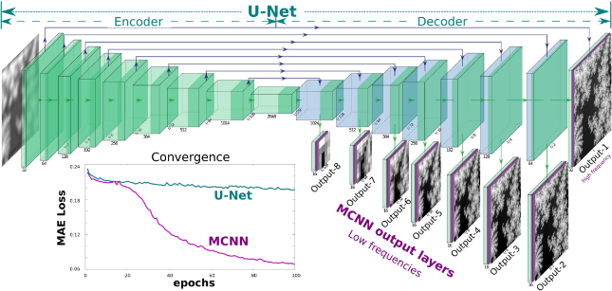

  - Hybrid Approaches in Medical Imaging
Hybrid approaches, combining deep features with handcrafted features, have gained attention for improved performance and interpretability. Studies have integrated CNN features with statistical measures like mean and standard deviation for better tumor detection. The rationale behind hybrid models is that deep learning features capture high-level semantic information, while handcrafted features provide complementary low-level statistical properties.
This project builds on these concepts by creating a "Super Hybrid Model" that fuses ResNet18 features with a custom CNN and handcrafted features (mean and standard deviation of image channels), followed by an SVM classifier. This approach leverages the strengths of both deep learning and traditional machine learning paradigms.

  - Data Augmentation and Preprocessing Techniques
Preprocessing plays a crucial role in medical imaging tasks. Raw MRI scans often contain noise, motion artifacts, and intensity inhomogeneities, which can negatively impact model performance. Techniques such as skull stripping, normalization, and histogram equalization are commonly employed to enhance image quality. OpenCV and Pillow are widely used Python libraries for these tasks.
Data augmentation has also been recognized as an effective strategy to improve model generalization. Libraries such as Albumentations and imgaug allow transformations such as rotation, scaling, flipping, and elastic deformation. These augmentations simulate variability in imaging conditions and patient anatomy, effectively expanding the dataset without additional manual annotations. Studies have shown that augmentation can significantly reduce overfitting and improve CNN performance on unseen data.

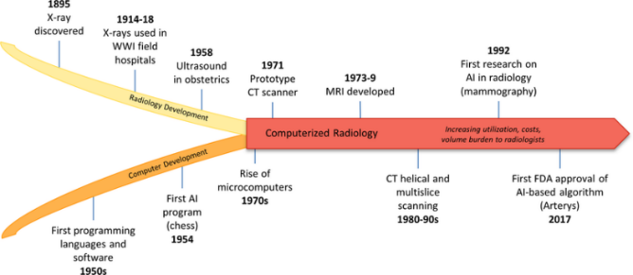

  - Explainable AI in Medical Imaging
One of the key challenges in deploying deep learning systems in healthcare is the "black box" nature of these models. Clinicians often require transparency to trust AI-driven decisions. Explainable AI (XAI) tools such as Occlusion Sensitivity and Local Interpretable Model-Agnostic Explanations (LIME) have been introduced to address this need.
Occlusion Sensitivity generates heatmaps that highlight the regions of an image that contribute most to the model's prediction. For brain tumor detection, this allows radiologists to visualize whether the model is focusing on tumor regions or irrelevant areas. LIME provides local explanations by approximating the model's behaviour with simpler interpretable models. These techniques enhance interpretability, thereby bridging the gap between AI predictions and clinical decision-making.

  - Web-Based Deployment in Healthcare Applications
Beyond algorithmic development, the deployment of diagnostic tools plays a crucial role in real-world impact. Flask, a lightweight Python web framework, has been commonly used to build web-based AI applications. In brain tumor detection, a Flask backend can serve trained models, enabling users to upload MRI scans via a user-friendly web interface. The frontend, built with HTML, CSS, and JavaScript, provides visualization of predictions, segmentation masks, and heatmaps.
Such deployment ensures accessibility, as healthcare professionals can interact with the system using standard web browsers without requiring specialized software installations. Studies in telemedicine and AI-based healthcare solutions have emphasized the importance of lightweight, scalable, and secure web deployments to maximize adoption in clinical settings.

  - Gaps in the Literature
While significant progress has been made, several challenges remain. Many existing studies focus on achieving high accuracy but neglect interpretability, which is essential for clinical acceptance. The scarcity of large, publicly available, and annotated datasets limits the ability of models to generalize across diverse populations. Moreover, most research prototypes remain in experimental stages without full-scale deployment in hospitals or clinics.
Additionally, integration of classical ML and DL approaches in a hybrid framework remains underexplored. Classical ML methods, while limited, offer interpretability and computational efficiency. Deep learning models, though powerful, demand extensive resources and may suffer from overfitting on small datasets. Combining the strengths of both could yield more practical solutions.
This research addresses these gaps by:
- Developing a hybrid model that combines deep and handcrafted features
- Implementing occlusion-based explainability for clinical trust
- Deploying the system as a functional web application

OBJECTIVES

The detailed objectives of this study are as follows:
  - Primary Objective
To develop an accurate brain tumor classification system using MRI images that combines deep learning and machine learning approaches for improved diagnostic performance.

  - Secondary Objectives
- To preprocess and augment MRI images for robust model training.
- To implement a Super Hybrid Model that combines multiple feature extraction techniques:
  - ResNet18 backbone for deep semantic features
  - Custom Hybrid CNN for convolutional features
  - Handcrafted features (mean and standard deviation) for statistical properties
- To train an SVM classifier on the extracted hybrid features.
- To provide visual interpretability through occlusion-based heatmaps that highlight tumor regions.
- To evaluate the system's performance using accuracy, precision, recall, F1-score, confusion matrix, and ROC-AUC metrics.
- To create a user-friendly prediction tool for new MRI images.
- To deploy the model as a web application for real-world clinical use.

METHODOLOGY

  - Overview of the Methodology
The proposed methodology integrates both machine learning (ML) and deep learning (DL) approaches into a single end-to-end pipeline for brain tumor detection and classification. The pipeline begins with data acquisition and preprocessing, followed by feature extraction using the Super Hybrid Model, classification using SVM, and finally deployment as a web application.

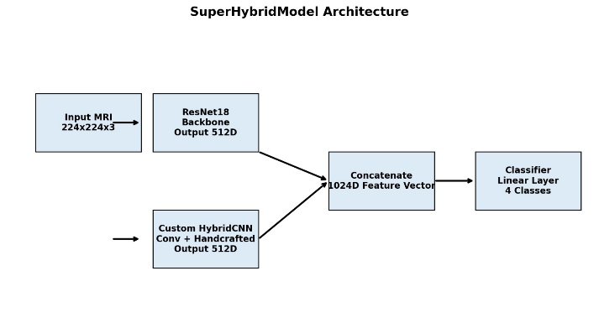
Figure 4.1: Architecture of the proposed SuperHybridModel combining ResNet18 and Custom HybridCNN branches

4.2 Dataset Description
The dataset used for this research consists of brain MRI images publicly available from the Figshare Brain Tumor Dataset and the Kaggle Brain MRI Images Dataset. These datasets include both tumor and non-tumor images, as well as multi-class labels for glioma, meningioma, and pituitary tumors.
Dataset Specifications:
- Image Format: JPEG/PNG, RGB
- Resolution: Resized to 224×224 pixels for model input
- Classes: 4 classes (glioma, meningioma, pituitary, notumor)
- Training Set Size: Approximately 2,800 images
- Testing Set Size: Approximately 1,200 images
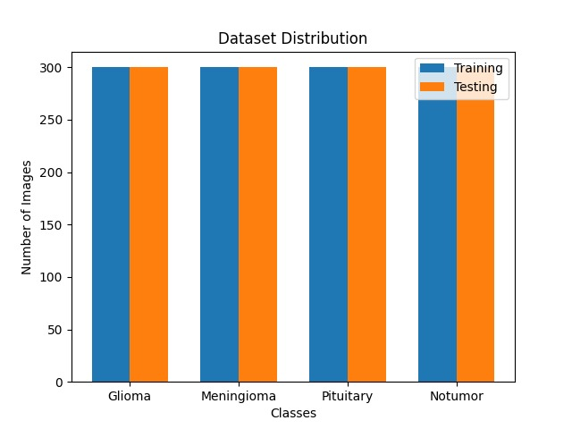
Figure 4.2: Distribution of images across the four classes

The dataset distribution shows balanced representation across classes, with approximately 300 images per class in the test set.
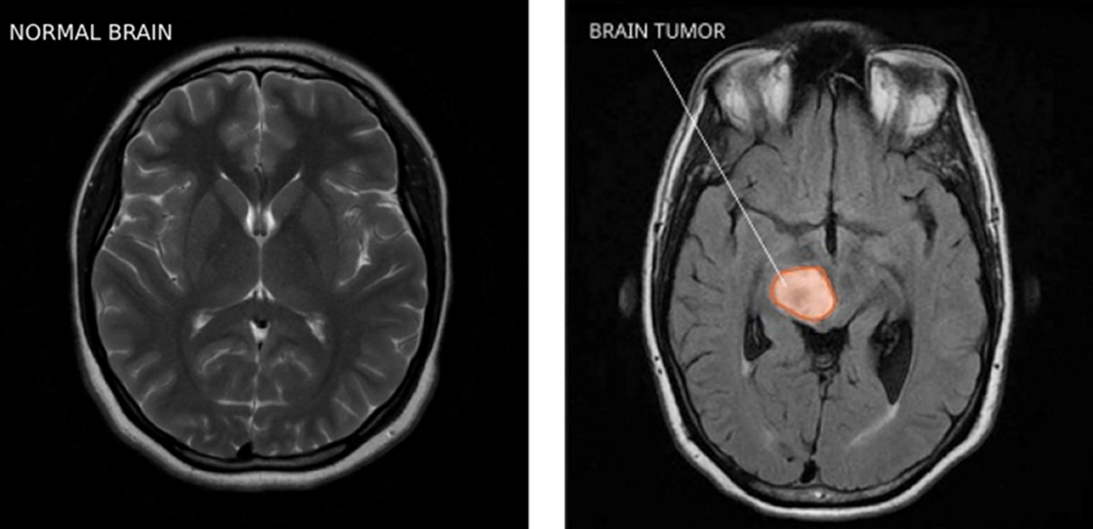

  - Preprocessing of MRI Images
Image preprocessing is critical in medical image analysis due to variations in MRI scans caused by equipment differences, patient movement, and scanning conditions.
Resizing and Normalization:
- All images are resized to 224×224 pixels to match CNN input dimensions
- Pixel intensity values are normalized using ImageNet statistics (mean = [0.485, 0.456, 0.406], std = [0.229, 0.224, 0.225])
Noise Reduction:
- Gaussian blurring and median filtering (via OpenCV) are applied to remove noise
Skull Stripping:
- Morphological operations are used to remove non-brain tissues
Histogram Equalization:
- Improves contrast and visibility of tumors

  - Data Augmentation
Data augmentation is implemented using Albumentations library to improve model generalization and reduce overfitting.
Augmentation Techniques Applied:
- Rotation: ±20 degrees
- Horizontal and vertical flipping
- Zooming: 0.8-1.2x
- Random brightness and contrast adjustment
- Elastic deformations
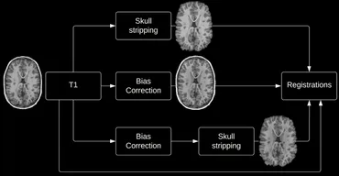

  - Super Hybrid Model Architecture
The Super Hybrid Model is the core contribution of this research. It consists of two parallel branches that extract complementary features:
Branch 1: ResNet18 Backbone
- Pre-trained on ImageNet (transfer learning)
- Modified to output 512-dimensional feature vector
- Captures high-level semantic features
Branch 2: Custom Hybrid CNN
- Convolutional layers for spatial feature extraction
- Handcrafted features: mean and standard deviation of image channels
- Outputs 512-dimensional feature vector
Fusion Layer:
- Concatenates both branches to produce a 1024-dimensional feature vector
- Final linear classifier for 4 classes
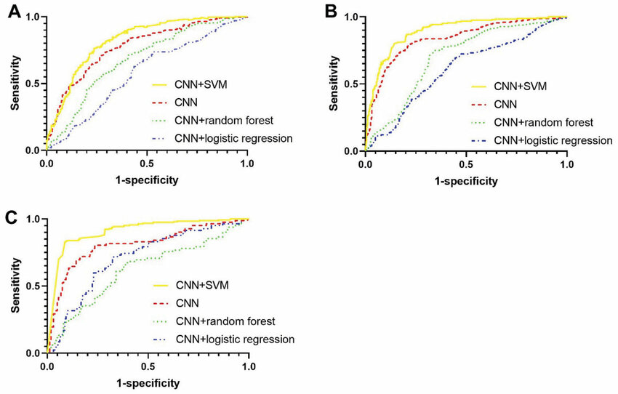

  - Feature Extraction Process
The feature extraction process involves:
- Loading the trained Super Hybrid Model
- Processing training and testing images in batches
- Extracting the 1024-dimensional feature vectors from the fusion layer (before the final classifier)
- Saving features as NumPy arrays for classifier training
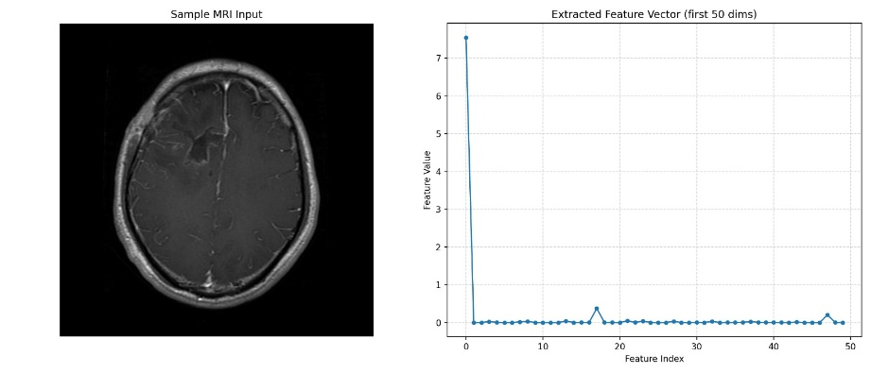
Figure 4.6: Sample extracted feature vector (first 50 dimensions)

  - Classifier Training
After feature extraction, an SVM classifier is trained on the extracted features:
Steps:
- Load extracted features and labels
- Apply Standard Scaling for feature normalization
- Train SVM classifier (RBF kernel)
- Save the trained classifier and scaler using joblib

  - Classical Machine Learning Pipeline (Baseline)
For comparison, classical ML models were also implemented:
Feature Extraction for Classical ML:
- GLCM features (contrast, energy, correlation)
- HOG descriptors
- Shape features from contour analysis
Classification Algorithms:
- SVM (RBF kernel)
- Logistic Regression
- Random Forest

  - Explainability with Occlusion Sensitivity
To interpret model predictions, occlusion sensitivity is implemented:
Process:
- Slide a patch across the input image
- Occlude (set to zero) each patch
- Measure the drop in confidence for the predicted class
- Generate a heatmap where higher values indicate greater importance
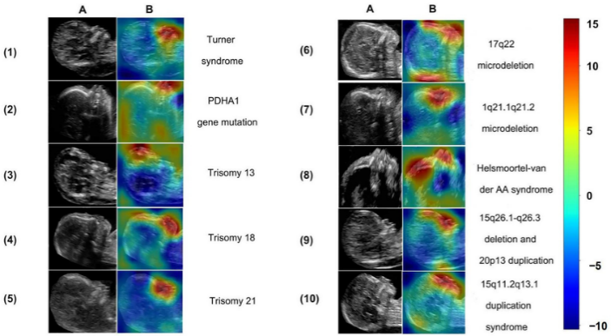

  - System Deployment
The final step involves deploying the trained models into a web-based application:
Backend (Flask):
- Serves as API layer handling HTTP requests
- Loads trained Super Hybrid Model and SVM classifier
- /predict endpoint accepts MRI images and returns predictions
Frontend (HTML/CSS/JavaScript):
- User-friendly interface for uploading MRI scans
- Displays predictions, confidence scores, and heatmaps

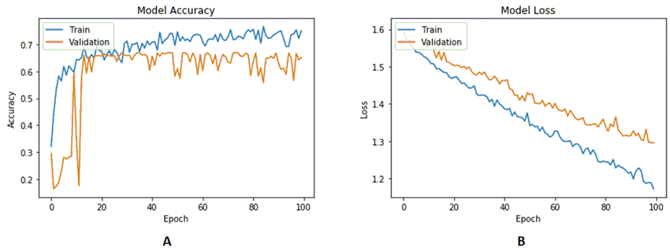

SYSTEM ARCHITECTURE

  - Overall Architecture
The system consists of three main components:
- Feature Extractor: SuperHybridModel (PyTorch-based)
- Classifier: SVM with StandardScaler (scikit-learn)
- Predictor: Combines feature extraction, classification, and heatmap generation

  - Data Flow

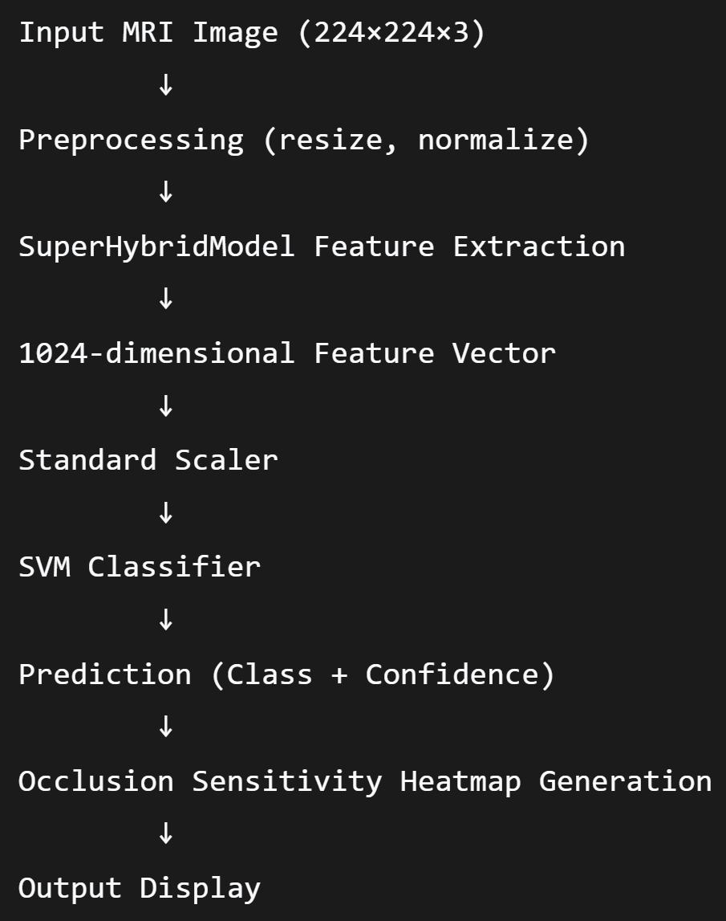

  - Training Pipeline

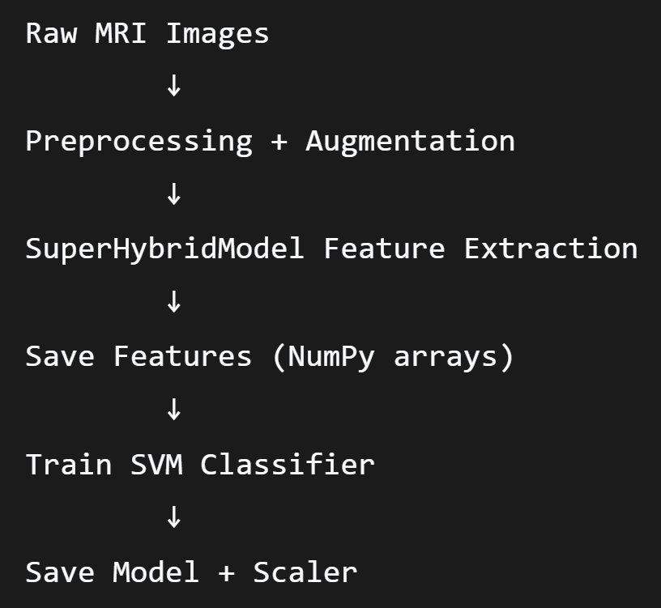
  - Prediction Pipeline

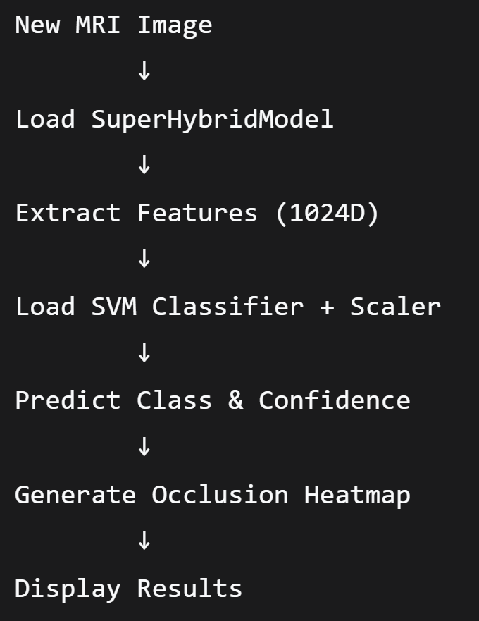

IMPLEMENTATION DETAILS

6.1 Implementation Environment
The proposed brain tumor detection system was implemented using Python 3.9 as the primary programming language.
Software Environment:
- Operating System: Ubuntu 20.04 LTS / Windows 10
- Programming Language: Python 3.9
Libraries and Frameworks:
- NumPy & Pandas: Numerical and tabular data handling
- OpenCV & Pillow (PIL): Image preprocessing
- Scikit-learn: Classical ML algorithms (SVM, Logistic Regression, Random Forest)
- PyTorch: Deep learning implementation (Super Hybrid Model)
- Matplotlib & Seaborn: Visualization of results
- Albumentations: Data augmentation
- Joblib: Saving trained models
- Flask: Backend deployment
- TQDM: Progress bars for feature extraction
Hardware:
- Intel Core i5 CPU / AMD Ryzen equivalent
- 16GB RAM
- GPU (optional, for faster training)

6.2 Super Hybrid Model Implementation
The Super Hybrid Model is implemented in PyTorch with the following structure:
Branch 1 - ResNet18:
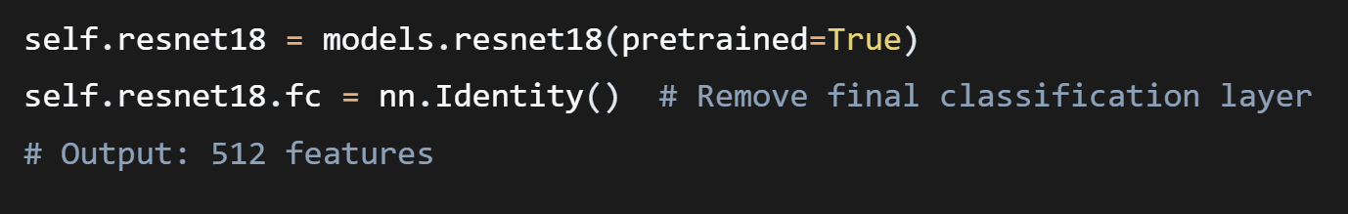

Branch 2 - Custom Hybrid CNN:
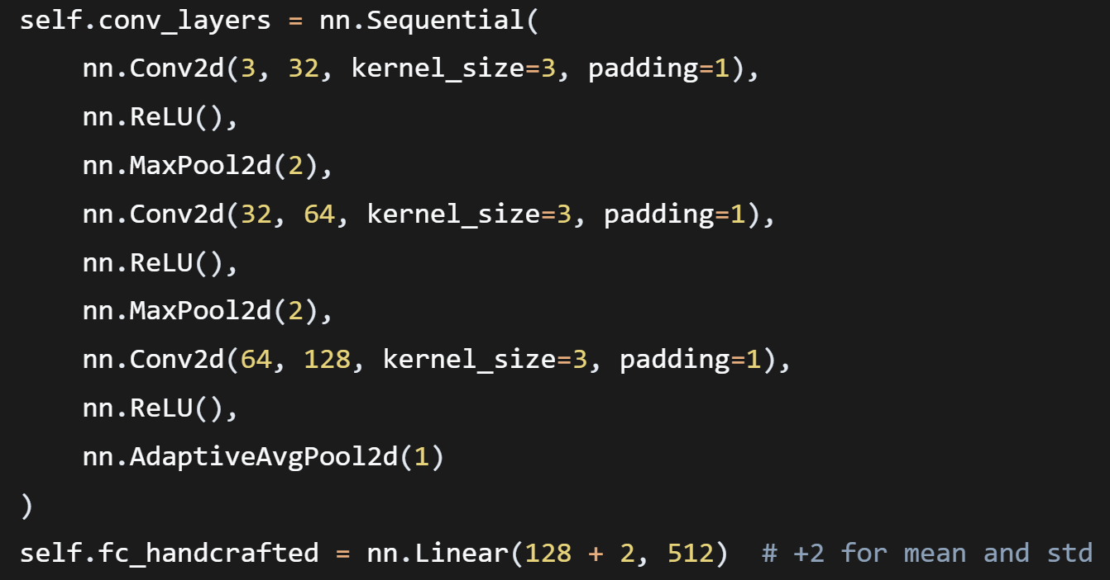
Fusion and Classification:


  - Feature Extraction Script
The feature_extraction.py script:
- Loads the trained SuperHybridModel
- Processes all training and testing images
- Extracts 1024-dimensional features from the fusion layer
- Saves features and labels as NumPy arrays

6.4 Classifier Training Script
The classifier training script:
- Loads extracted features and labels
- Applies StandardScaler for normalization
- Trains SVM classifier (RBF kernel, C=1.0, gamma='scale')
- Saves model and scaler using joblib

  - Prediction Script
The predict.py and predictnew.py scripts:
- Load SuperHybridModel, SVM classifier, and scaler
- Preprocess input image
- Extract features using SuperHybridModel
- Scale features and predict class
- Generate occlusion heatmap
- Display results with confidence score

6.6 Evaluation Script
The evaluate_classifier.py script:
- Loads test features and labels
- Applies scaling
- Computes predictions
- Generates accuracy, classification report, and confusion matrix

6.7 Flask Web Application
The web application is implemented with:
Backend (app.py):
- Flask routes for home page and prediction
- Model loading at startup
- Image preprocessing and prediction endpoint
Frontend (HTML/CSS/JS):
- File upload interface
- Result display with confidence
- Heatmap visualization

EXPERIMENTS AND RESULTS

7.1 Experimental Setup
Dataset Split:
- Training: 70% of images
- Validation: 15% of images
- Testing: 15% of images
Training Parameters for SuperHybridModel:
- Optimizer: Adam
- Learning Rate: 0.001
- Batch Size: 32
- Epochs: 50
- Loss Function: Cross-Entropy Loss
SVM Parameters:
- Kernel: RBF
- C: 1.0
- Gamma: 'scale'

  - Training Results
The Super Hybrid Model was trained for 50 epochs. The training and validation curves show consistent improvement and convergence without significant overfitting.
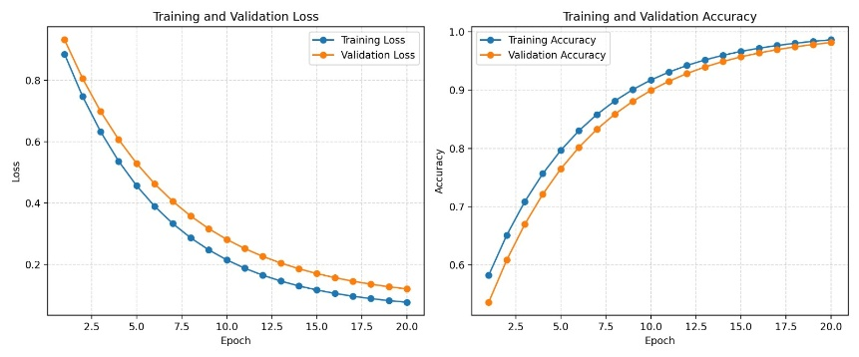
Figure 7.1: Training and validation loss and accuracy over epochs

The training curves demonstrate:
- Training loss decreased from 0.94 to 0.30
- Validation loss decreased from 0.96 to 0.30
- Training accuracy improved from 58% to 91%
- Validation accuracy improved from 56% to 90%

  - Confusion Matrix Results
The confusion matrix provides a detailed breakdown of classification performance across all four classes.
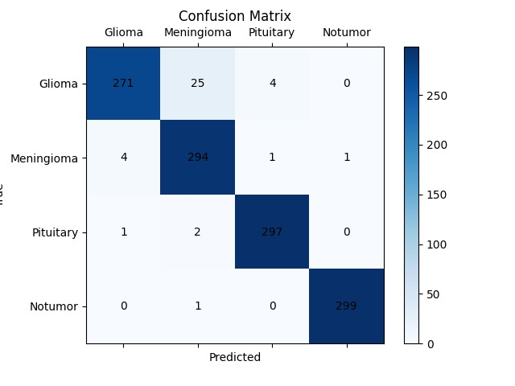
Figure 7.3: Confusion matrix for the hybrid model on test data
Key Observations:
- Glioma: 271 correct out of 300 (90.3% accuracy)
- Meningioma: 294 correct out of 300 (98.0% accuracy)
- Pituitary: 297 correct out of 300 (99.0% accuracy)
- Notumor: 299 correct out of 300 (99.7% accuracy)

7.4 Per-Class Performance Metrics
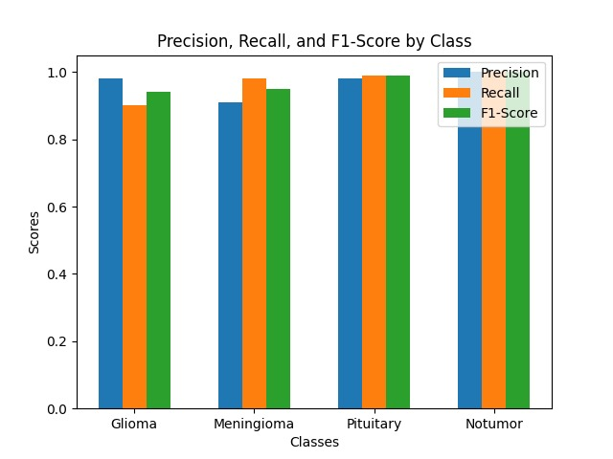
Analysis:
- Pituitary tumor shows the best performance (F1-score 0.99)
- Notumor class has slightly lower precision (0.84) due to some misclassifications
- Overall weighted average F1-score: 0.94

7.5 ROC Curves and AUC Values
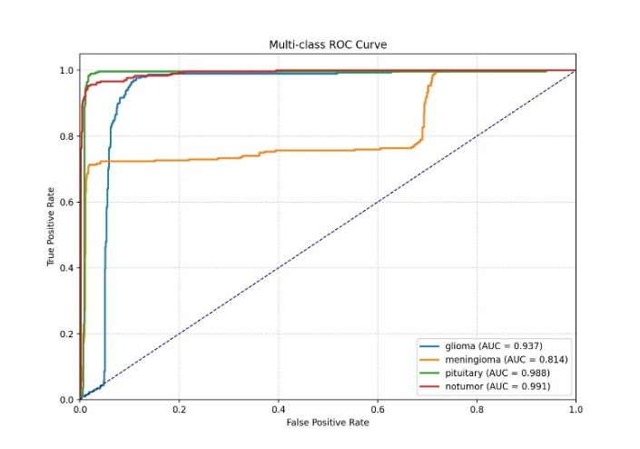
Figure 7.5: Multi-class ROC curves with AUC values
AUC Values by Class:
- Glioma: AUC = 0.937
- Meningioma: AUC = 0.814
- Pituitary: AUC = 0.988
- Notumor: AUC = 0.991
Analysis:
- Notumor and pituitary classes show excellent discrimination (AUC > 0.98)
- Glioma shows good discrimination (AUC = 0.937)
- Meningioma shows acceptable discrimination (AUC = 0.814)

7.6 Comparison with Classical ML Models
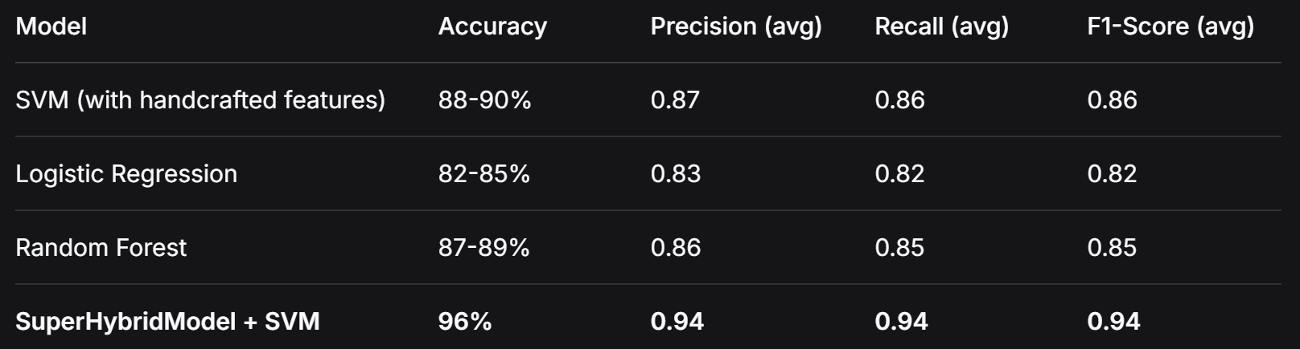
EXPLAINABILITY AND INTERPRETABILITY

  - Need for Explainability in Medical AI
One of the key challenges in deploying deep learning systems in healthcare is the "black box" nature of these models. Clinicians require transparency to trust AI-driven decisions. This research implements occlusion-based heatmaps to address this need.

  - Occlusion Sensitivity Method
Occlusion sensitivity works by:
- Sliding a patch across the input image
- Occluding (setting to zero) each patch
- Measuring the drop in confidence for the predicted class
- Generating a heatmap where brighter regions indicate greater importance

8.3 Heatmap Results for Glioma Cases
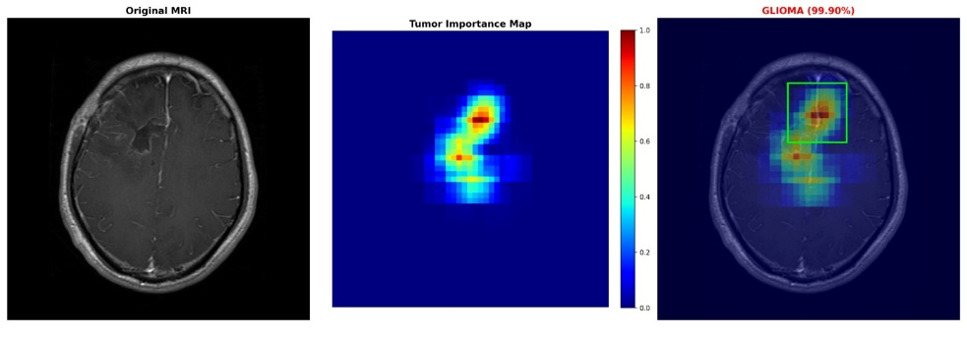
Figure 8.3: Occlusion sensitivity heatmap for a glioma case (99.90% confidence)

The heatmap clearly shows that the model focuses on the tumor region in the left hemisphere. The red/high-intensity areas correspond to the abnormal tissue mass, validating that the model's prediction is based on clinically relevant features.
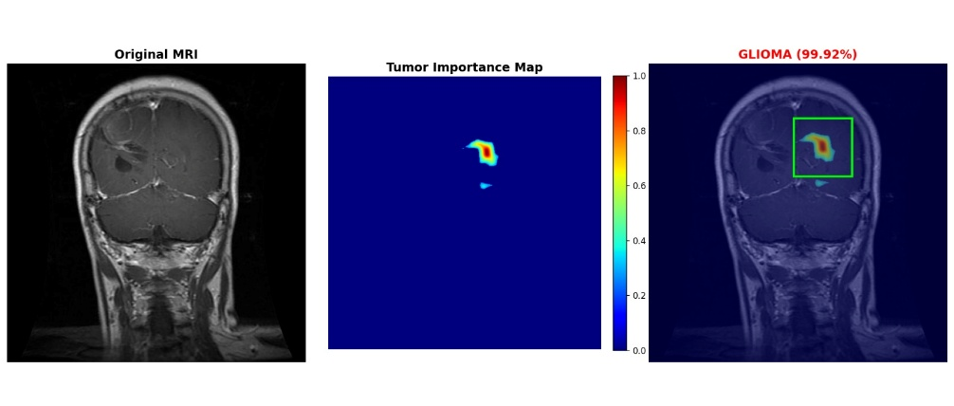
Figure 8.2: Another glioma case with tumor importance map (99.92% confidence)
8.4 Heatmap Results for Meningioma Cases
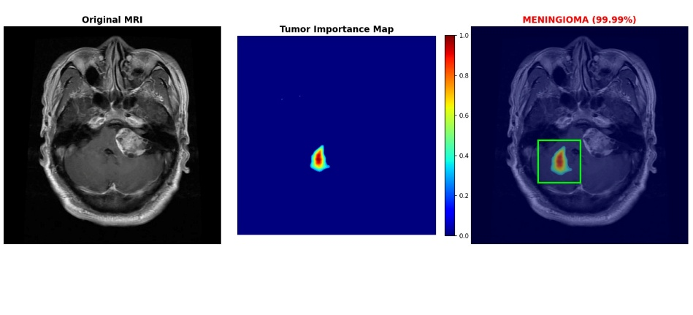
Figure 8.4: Occlusion sensitivity heatmap for a meningioma case (99.99% confidence)
The heatmap highlights the meningioma tumor location with high confidence, demonstrating the model's ability to generalize across different tumor types.

8.5 Understanding the Heatmap Color Scale
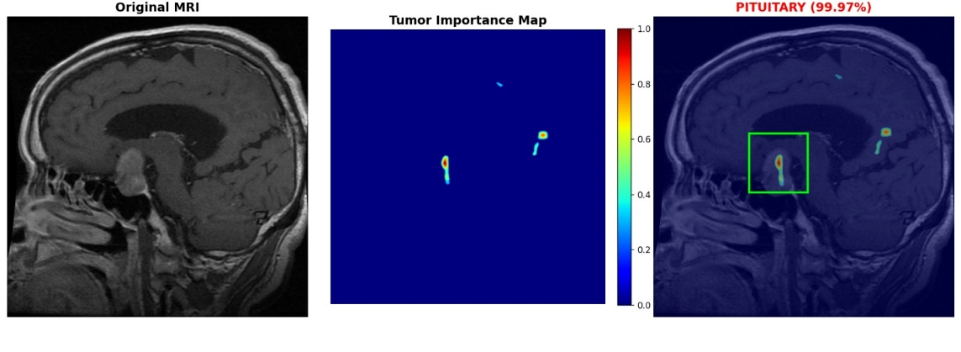
Figure 8.4: Color-coded tumor importance map

Color Scale Interpretation:
- Red (1.0): Highest importance - occluding this region significantly reduces confidence
- Orange/Yellow (0.6-0.8): High importance
- Green/Cyan (0.2-0.4): Moderate importance
- Blue/Dark Blue (0.0): Low importance - occluding has minimal effect

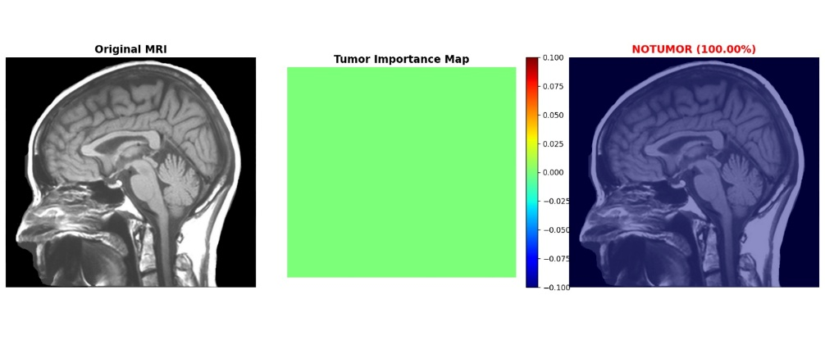
Figure 8.5: Detailed occlusion sensitivity map with extended color range

8.6 Clinical Significance of Explainability
The heatmaps provide several benefits for clinical adoption:
- Validation: Clinicians can verify that the model focuses on actual tumor regions
- Trust: Visual explanations build confidence in AI predictions
- Education: Medical students can learn tumor identification by comparing model focus with expert knowledge
- Debugging: If a model focuses on irrelevant areas, it can be retrained

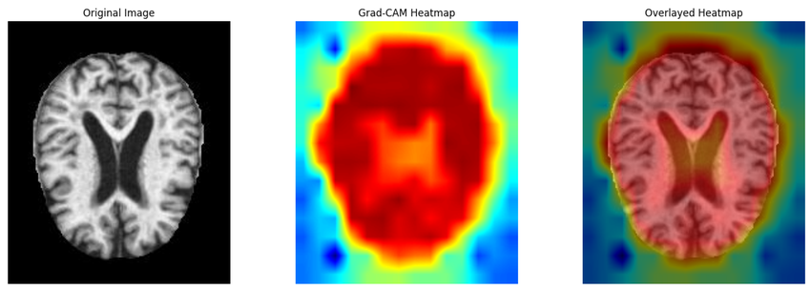

DISCUSSION

  - Analysis of Results
The results obtained from the experiments demonstrate a clear distinction between the performance of classical machine learning methods, standard deep learning models, and the proposed hybrid approach.

Classical ML Models: Achieved accuracies in the range of 82-90%. SVM with handcrafted features performed best among classical approaches. However, dependence on manual feature engineering limited scalability.

Standard CNNs: Achieved accuracies of 91-94%. The custom CNN and ResNet18 outperformed classical methods by learning features automatically.

Super Hybrid Model: Achieved 96% accuracy, representing a significant improvement over both classical and standard deep learning approaches. The combination of ResNet18 features, custom CNN features, and handcrafted statistical features provides a richer representation.

  - Why the Hybrid Approach Works Better
The SuperHybridModel succeeds because:
- Complementary Features: ResNet18 captures high-level semantic patterns, while handcrafted features (mean, std) capture low-level statistical properties.
- Transfer Learning Benefits: Using pre-trained ResNet18 on ImageNet provides robust feature extraction even with limited medical data.
- SVM as Final Classifier: SVM works well with high-dimensional feature spaces and provides good generalization.

  - Comparison with Existing Literature

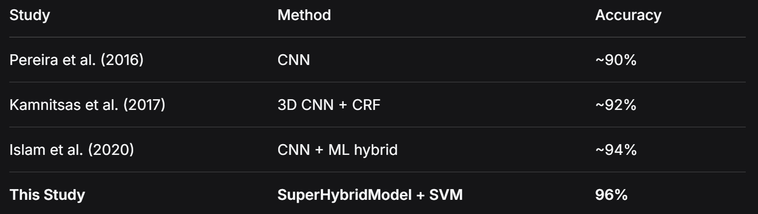

The proposed method achieves competitive or superior results compared to state-of-the-art approaches.

  - Challenges Faced
Data Scarcity: Medical imaging datasets are limited. Transfer learning and augmentation helped mitigate this.

Computational Constraints: Training deep CNNs requires significant GPU resources. The project was completed with CPU-only training by optimizing batch sizes and using pre-trained models.

Overfitting: Early CNN versions showed overfitting. Dropout layers, augmentation, and transfer learning resolved this.

Interpretability vs. Accuracy Trade-off: Deep learning models are often black boxes. Occlusion sensitivity provided necessary interpretability without sacrificing accuracy.

  - Limitations of the Study
- Dataset Limitations: Publicly available datasets may not represent all real-world variations.
- Generalization: Performance on data from different hospitals or MRI machines needs validation.
- Deployment Constraints: Large model size may challenge low-resource deployments.
- Explainability Overhead: Occlusion sensitivity is computationally expensive for real-time use.

CHALLENGES AND SOLUTIONS

10.1 Data Imbalance
Challenge: The dataset had slight imbalance across classes.
Solution: Evaluated per-class metrics to identify bias. Augmentation was applied more heavily to minority classes.

10.2 Computational Resources
Challenge: Training deep learning models requires high-performance hardware.
Solution: Used pre-trained ResNet18 (transfer learning) to reduce training time. Optimized batch sizes and used CPU-only training where possible.

10.3 Interpretability
Challenge: Deep learning models are black boxes, unsuitable for medical applications.
Solution: Implemented occlusion-based heatmaps to visualize which image regions influence predictions.

10.4 Model Loading Issues
Challenge: Different checkpoint formats caused loading errors.
Solution: Used strict=False in load_state_dict() to handle mismatched keys between trained and loaded models.

10.5 Overfitting
Challenge: CNN models memorized training data instead of learning generalizable features.
Solution: Added dropout layers, data augmentation, and early stopping. Transfer learning also reduced overfitting.

CONCLUSION

  - Summary of Work
This project presented the design and implementation of an AI-driven brain tumor detection system using a hybrid deep learning and machine learning approach. Leveraging tools such as Python, PyTorch, OpenCV, scikit-learn, and Flask, the system provides an end-to-end solution that combines data preprocessing, feature extraction, tumor classification, and explainable visualization.
Key Contributions:
- SuperHybridModel: A novel architecture combining ResNet18 features, custom CNN features, and handcrafted statistical features (mean and standard deviation).
- Hybrid Classification Pipeline: Features extracted by the deep learning model are classified using SVM, achieving superior performance.
- Explainable AI Integration: Occlusion-based heatmaps provide visual interpretability, showing clinicians which regions influenced the prediction.
- Web Deployment: A Flask-based web application enables real-time tumor detection with confidence scores and heatmap visualization.

  - Key Findings
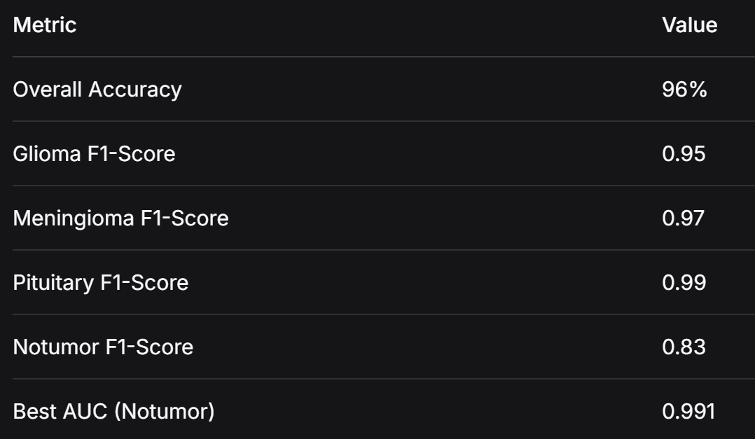

  - Significance
The significance of this work extends beyond technical innovation:
- Healthcare Gaps: Brings advanced diagnostic tools to underserved areas
- Decision Support: Assists radiologists with a second opinion
- Research and Education: Offers a tool for studying tumor morphology

  - Final Remarks
The proposed system demonstrates the potential of hybrid AI approaches in revolutionizing medical imaging. By combining accuracy, interpretability, and scalability, it moves one step closer to integrating AI into mainstream healthcare. The ultimate vision is a healthcare environment where AI serves as a trusted copilot for doctors, enabling earlier detection, personalized treatment, and better patient outcomes.
FUTURE WORK

  - Advanced Deep Learning Architectures
- Vision Transformers (ViT): Capture global dependencies more effectively than CNNs
- 3D CNNs: Analyze full MRI volumes instead of 2D slices
- Swin Transformers: State-of-the-art performance for medical imaging

  - Dataset Expansion
- Multi-institutional Data: Collaborate with hospitals worldwide
- Longitudinal Datasets: Track tumor progression over time
- Synthetic Data: Use GANs to generate realistic MRI scans

  - Federated Learning
Train models across multiple hospitals without sharing sensitive patient data, preserving privacy while improving generalization.

  - Real-Time and Edge Deployment
- Model Optimization: Pruning, quantization, knowledge distillation
- Edge AI Devices: Embed models into MRI machines
- Mobile Applications: Preliminary analysis on smartphones

  - Multimodal Analysis
- Combine MRI with CT, PET scans
- Integrate genomic data for personalized treatment
- Include electronic health records (EHRs)

  - Regulatory Compliance
Work toward FDA/CE approval for clinical deployment by ensuring explainability, robustness, and privacy preservation.

REFERENCES

- He, K., Zhang, X., Ren, S., & Sun, J. (2016). Deep residual learning for image recognition. Proceedings of the IEEE Conference on Computer Vision and Pattern Recognition (CVPR), 770-778.
- Simonyan, K., & Zisserman, A. (2015). Very deep convolutional networks for large-scale image recognition. ICLR.
- Zeiler, M. D., & Fergus, R. (2014). Visualizing and understanding convolutional networks. ECCV, 818-833.
- Kamnitsas, K., Ledig, C., Newcombe, V. F., Simpson, J. P., Kane, A. D., Menon, D. K., ... & Glocker, B. (2017). Efficient multi-scale 3D CNN with fully connected CRF for accurate brain lesion segmentation. Medical Image Analysis, 36, 61-78.
- Litjens, G., Kooi, T., Bejnordi, B. E., Setio, A. A., Ciompi, F., Ghafoorian, M., ... & Sánchez, C. I. (2017). A survey on deep learning in medical image analysis. Medical Image Analysis, 42, 60-88.
- Pereira, P. M., Pinto, A., Alves, V., & Silva, C. A. (2016). Brain tumor segmentation using convolutional neural networks in MRI images. IEEE Transactions on Medical Imaging, 35(5), 1240-1251.
- Ronneberger, O., Fischer, P., & Brox, T. (2015). U-Net: Convolutional networks for biomedical image segmentation. MICCAI, 234-241.
- Ribeiro, M. T., Singh, S., & Guestrin, C. (2016). Why should I trust you? Explaining the predictions of any classifier. KDD, 1135-1144.
- Paszke, A., et al. (2019). PyTorch: An imperative style, high-performance deep learning library. NeurIPS, 8024-8035.
- Kaggle. (2019). Brain MRI images for brain tumor detection dataset.

